Servlet Screen Prints: 1

Home Web Page (index.jsp): 1

Results if attacking Dallas, TX: 2

Results if attacking BYU Idaho: 2

Results if attacking Earth’s Moon: 3

Results if the player forgets to select a robot army: 3

Results if the Skaro applet is called via get rather than post: 3

# Servlet Screen Prints:

## Home Web Page (index.jsp):

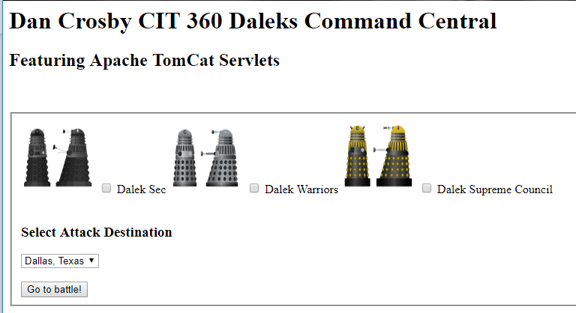

## Results if attacking Dallas, TX:

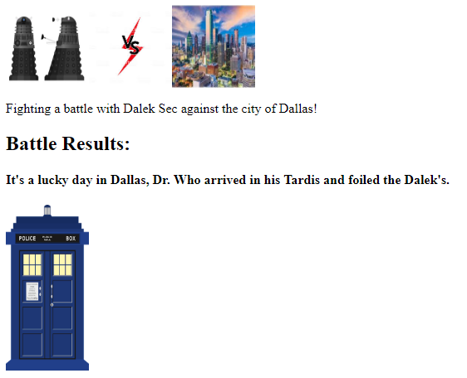

## Results if attacking BYU Idaho:

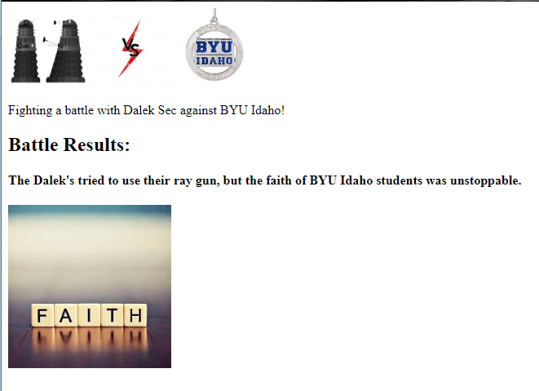

## Results if attacking Earth’s Moon:

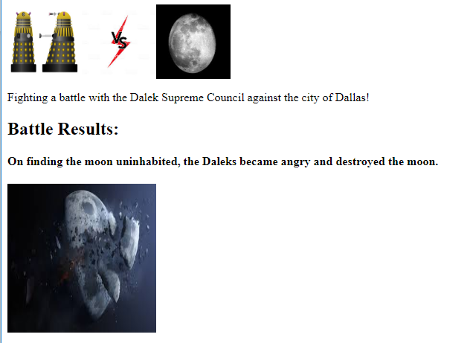

## Results if the player forgets to select a robot army:



Error handling results if the web page calling the servlet does not have the required field myTarget:

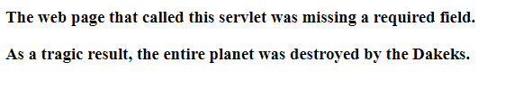

## Results if the Skaro applet is called via get rather than post:

